Riverina Poultry Farms – Pump Shed
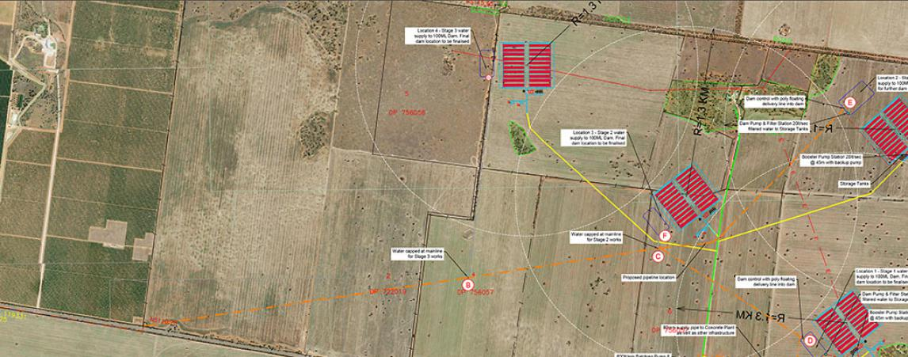

Project description
MI Channel Pump Station on channel adjacent to Tabbita Lane feeding 6km pipeline to 4 dams and 20 chicken sheds per dam
- Connection to MI channel allowing 6.5ML per day flow
- Electric pumping station capable of 6.5ML per day supply to various dams over the property
- 180lt/min Grundfos CRE 10-6 Jockey Pump
- Grundfos NBG electric pump 75kw 1450rpm 7Slt/sec @ 600kpa max to supply water to each dam
- 75kw variable speed drive and control from MAIT interface control
Concrete Batching Plant and Office for the production of chicken sheds
- Supply to 110,000lt Pioneer Steel Tank with covered roof. Up to 20,000lt/hour filling capacity
- Discharge from tanks will be plumbed to two pumps:
- Ebara Stainless Steel 600lt/min @ 10m transfer pump for filling the Concrete Plant
- Davey or Grundfos 1201t/min @ 35m Pressure System installed for taps, tyre wash system
- System Design from MI channel: 2,000lt/concrete batch x 10 batches/hr x 7hrs = 140,000lt or 70 batches. Refill time 13hrs/day from Booster Pump

Project details
The connection into Murrumbidgee Irrigation System and the mainlines back to the farm dams and concrete processing plant is a large undertaking. We look forward to the next phases in the project as the sheds start to develop.
Riverina Poultry3Appreciate
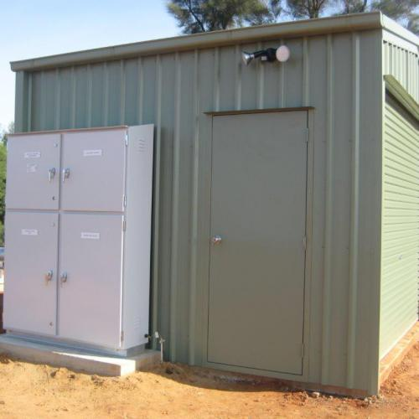
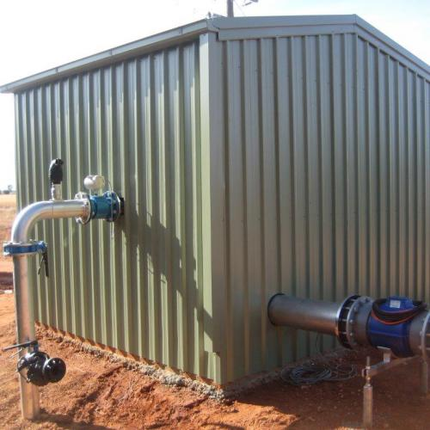
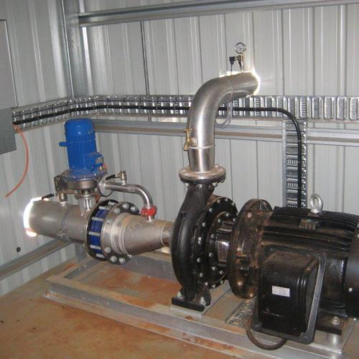
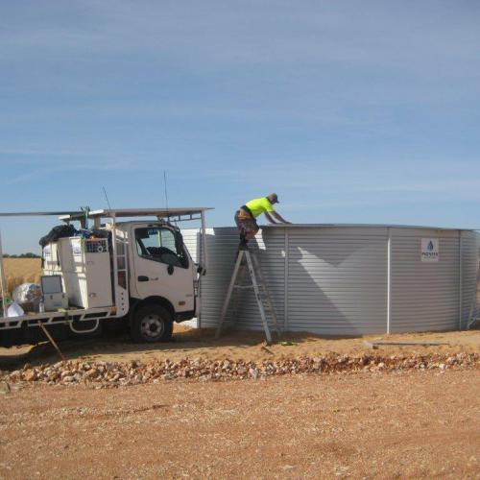
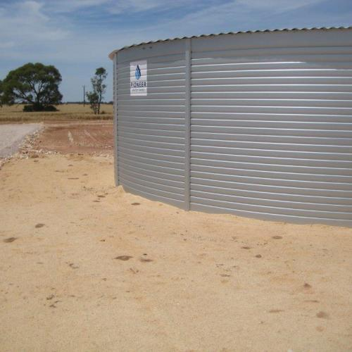
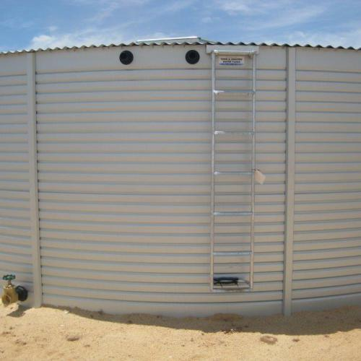
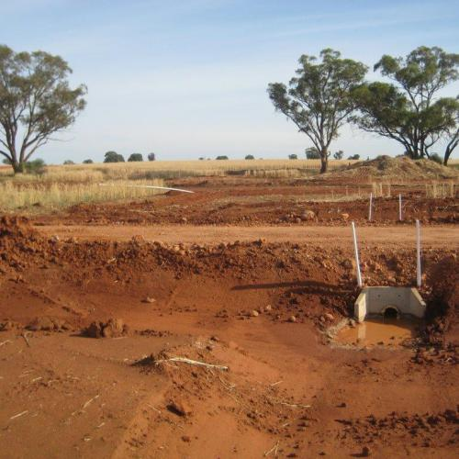
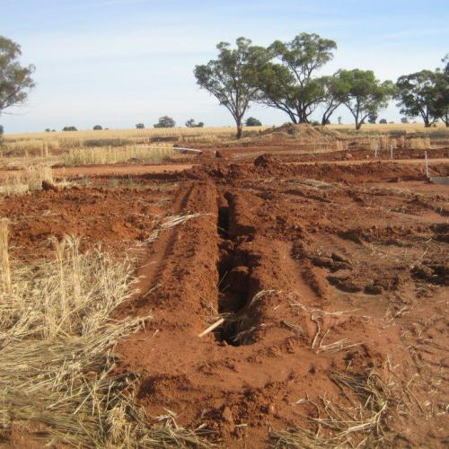
Contact Us

Interested? Contact Us for more information...

